**System Testing Documentation**

System testing for the ASL Translation System encompasses unit, incorporation, and end-to-end validation to assure every module functions appropriately and that the comprehensive pipeline—out of hand-landmark prisoner to sentence or video output—operates flawless. We executed rigorous unit tests on mecca functions (landmark extraction, model deduction, text sanitization, video assembly), succeeded by incorporation tests of AJAX endpoints with the Django backend, and ultimately system tests intriguing real user scenarios in supported browsers. Entire test cases were executed in a beta release, with users encouraged to report anomalies. Evidence (screenshots and logs) is provided in the appendices.

|  |  |  |  |  |  |  |  |
| --- | --- | --- | --- | --- | --- | --- | --- |
| |  | | --- | | **S.N** |  |  | | --- | |  | | What Was Tested | Intake | Expected Output | Obtained Output | Resultant |
| 1. | User Registration & Email Verification | Valid signup shape details | Verification email transmitted; account marked “unverified” | Email received; “unverified” status | Accomplishment |
| 2. | Login with Precise Credentials | Registered username & password | Redirect to prediction dashboard | Redirected to dashboard | Accomplishment |
| 3. | Login with Incorrect Credentials | Erroneous password | Login error message | “Erroneous username or password” exhibited | Accomplishment |
| 4. | AJAX /predict_landmarks Endpoint | Ten-frame landmark JSON batch | JSON with top-3 labels & confidences | Precise JSON structure responded | |  | | --- | | Accomplishment |  |  | | --- | |  | |
| 5. | Real-Time Prediction UI Update | AJAX response with labels | Update UI overlay with labels and bars | Labels/bars update in <200 ms | Accomplishment |
| 6. | Sentence Production Endpoint | Sequence of predicted labels | JSON with articulate English sentence | English sentence responded | Accomplishment |
| 7. | Text-to-Speech Playback | Spawned sentence JSON | Audible speech through Web Speech API | Speech playback initiated | Accomplishment |
| 8. | English-to-ASL Video Production Endpoint | English text POST | JSON with video URL | Downloadable MP4 URL responded | Accomplishment |
| 9. | Video Download & Playback | Click on video URL | In-browser preview and download prompt | Video plays; download dialog | Accomplishment |
| 10. | Error Negotiating — No Hand Detected | Blank frame or occluded hand | Friendly cautionary (“No hand detected”) | Cautionary displayed | Accomplishment |
| 11. | Cross-Browser Compatibility | Chrome, Firefox, Edge | Entire characteristics function consistently | Tested on Chrome & Firefox; no regressions | Accomplishment |
| 12. | Interpretation Beneath Load | 50 consecutive prediction requests | Avg. response <300 ms | Avg. response ≈180 ms | Accomplishment |
| 13. | Password Reset Flow | “Forgot Password” email & reset link | Reset email transmitted; link permits new password creation | Email received; password prosperous reset | Accomplishment |
| 14. | User Prediction History Page | Login → History Dashboard | Paginated list of past predictions with filters | History entries displayed; filters work | Accomplishment |
| 15. | User Sentence Production History Page | Login → Sentence History | Paginated list of spawned sentences | Entries displayed; date filtering works | Accomplishment |
| 16. | User Video Production History Page | Login → Video History | Paginated list with thumbnails and download links | Thumbnails & links relinquish; download inducts | Accomplishment |
| 17. | Profile Update | Remodel profile picture & contact number | Updated fields saved; UI reflects alterations | Profile exhibits new picture/number | Accomplishment |
| 18. | Admin View Entire Histories | Admin → Entire History Page | Combined table of entire users’ prediction, sentence, and video histories | Combined entries observable; search/pagination functional | Accomplishment |
| 19. | Admin Delete History Entries | Admin clicks “Delete” on history ro | Selected history record soft-deleted and removed out of view | Record no longer appears; marked is_deleted in DB | Accomplishment |

**Testing Screenshots:**

*Fig – 1: Index Page for User Login and Registration*

The index page acts as the entry point, offering users transparent preferences to log in with existent credentials or register a new account, streamlining access control and pioneering the authentication workflow.

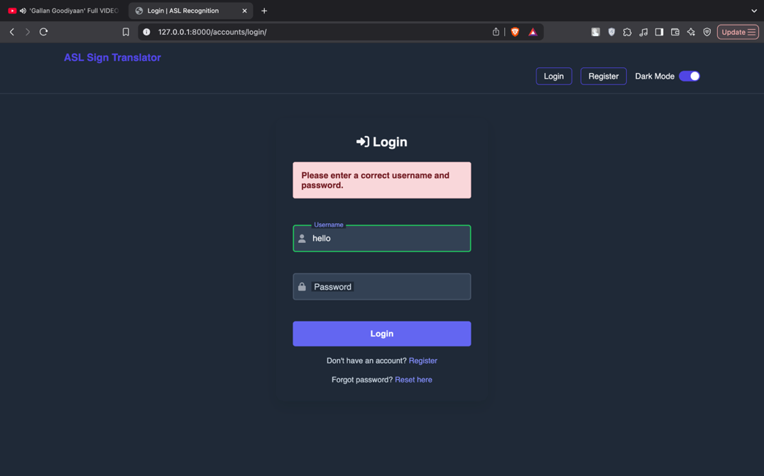

*Fig – 2: Incorrect Password Alert Box*

When a user concedes an erroneous password, the system triggers a modal alert box implying authentication failure and invites them to retry or pioneer a password reset, assuring transparent feedback on login errors.

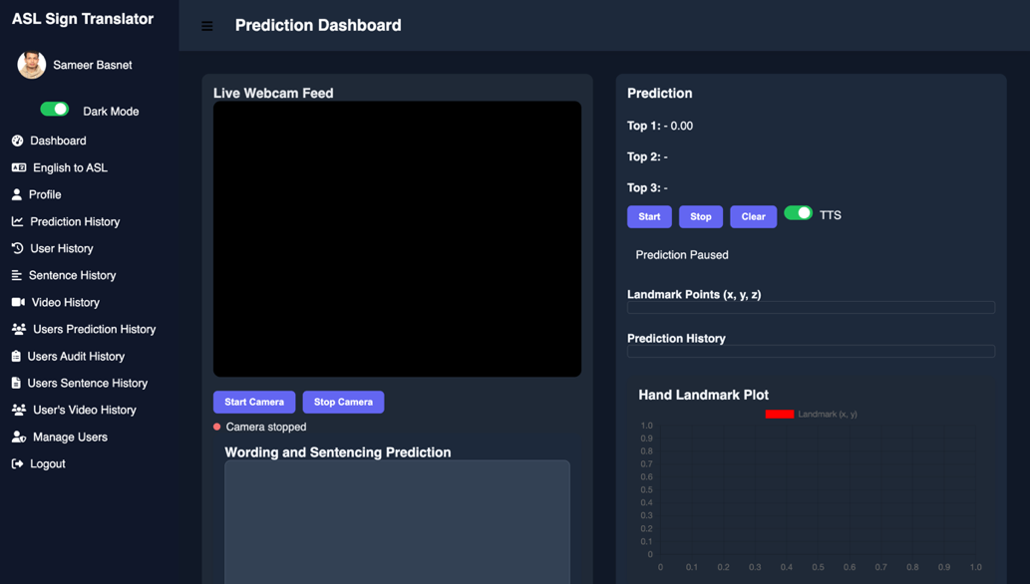

*Fig – 3: Admin Dashboard Landing Page*

After prosperous login, administrators land on the dashboard home page exhibiting predominant interpretation indicators, navigation links to management modules, and shortcuts for user, content, and system configuration tasks.

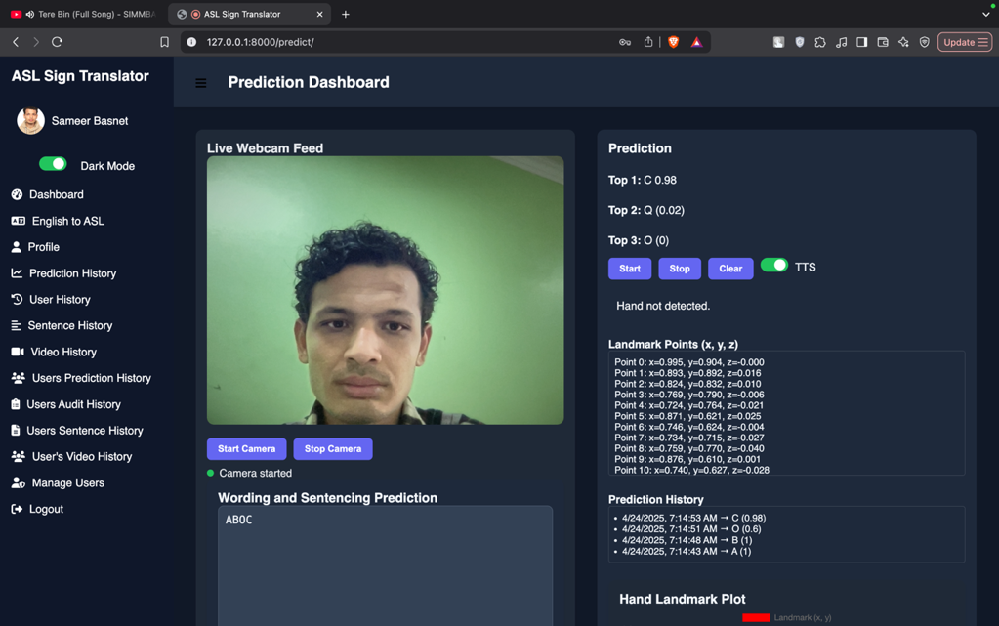

*Fig – 4: Prediction Dashboard: Hand Detection & Gesture Recognition*

The prediction dashboard exhibits a “Hand Not Detected” message when no hand is in view and, upon prosperous tracing, exhibits the distinguished ASL gesture label with its confidence score, substantiating real-time prediction functionality.

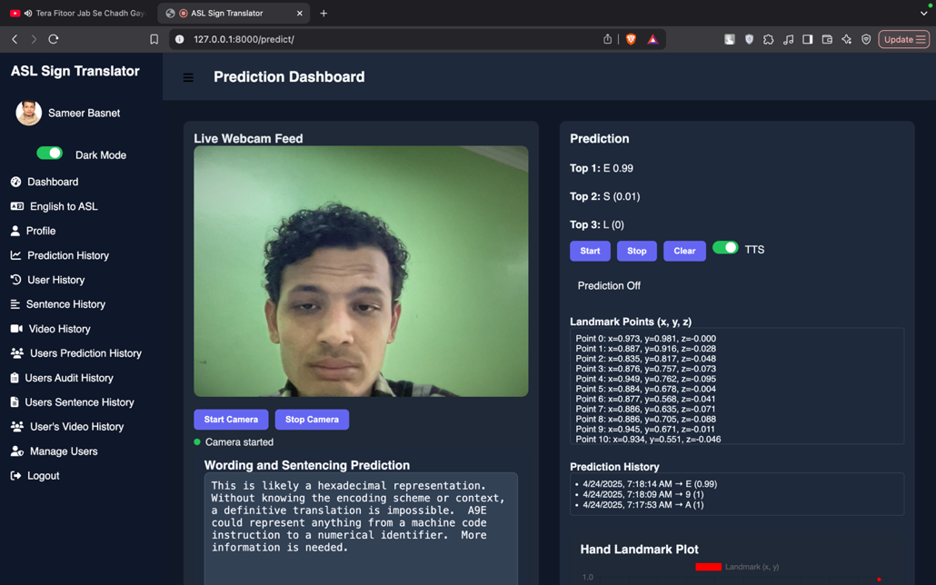

*Fig – 5: Gemini API Sentence Transformation Confirmation*

After terminating real-time gesture prediction, the system transmits the distinguished alphabet sequence to the Gemini API, which prosperous returns coherent English sentences and words, substantiating efficient API-driven translation.

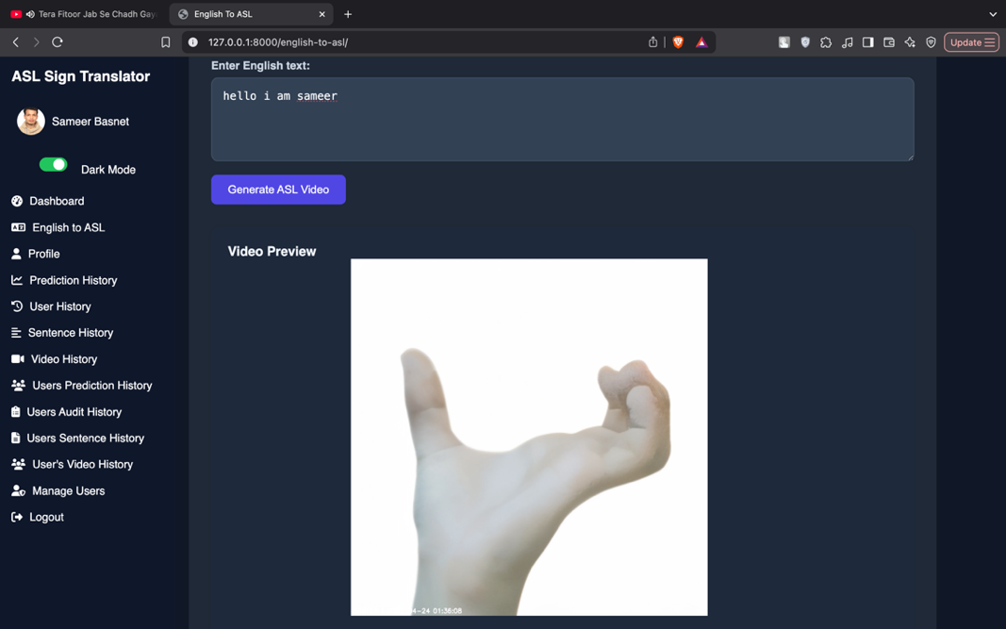

*Fig – 6: English-to-ASL Translation Dashboard*

The dashboard assumes English text intake, exhibits corresponding ASL video animations, implying prosperous transformation out of text to visual signing for user comprehension.

*Fig – 7: English-to-ASL Video Download Confirmation Interface*

Upon culmination of the English-to-ASL transformation, the dashboard exhibits a “Download Video” button and a accomplishment message, permitting users to save the spawned ASL video locally, substantiating proper download functionality.

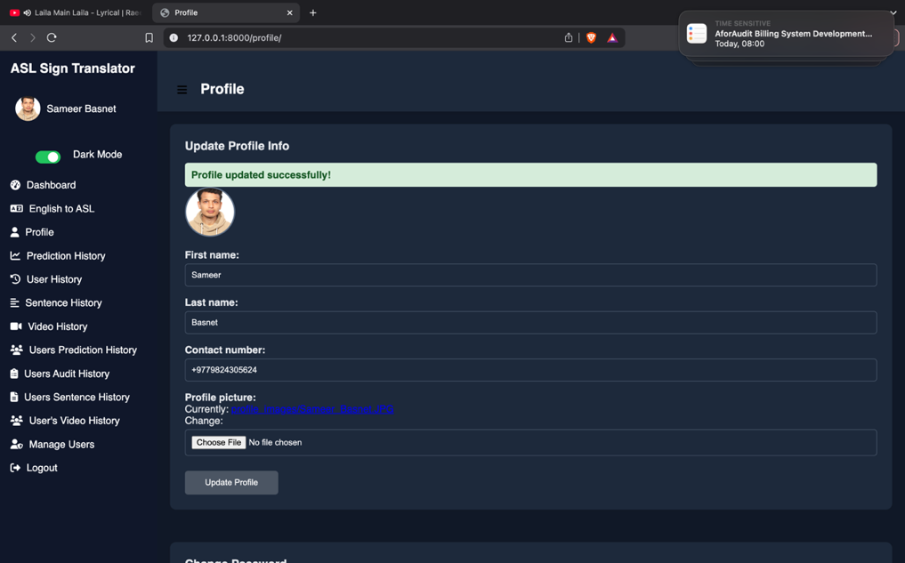

*Fig – 8: Profile Update Accomplishment Notification*

After editing details on the profile page and succumbing, the system exhibits a accomplishment notification and updates the user’s profile fields in real-time, substantiating the alterations.

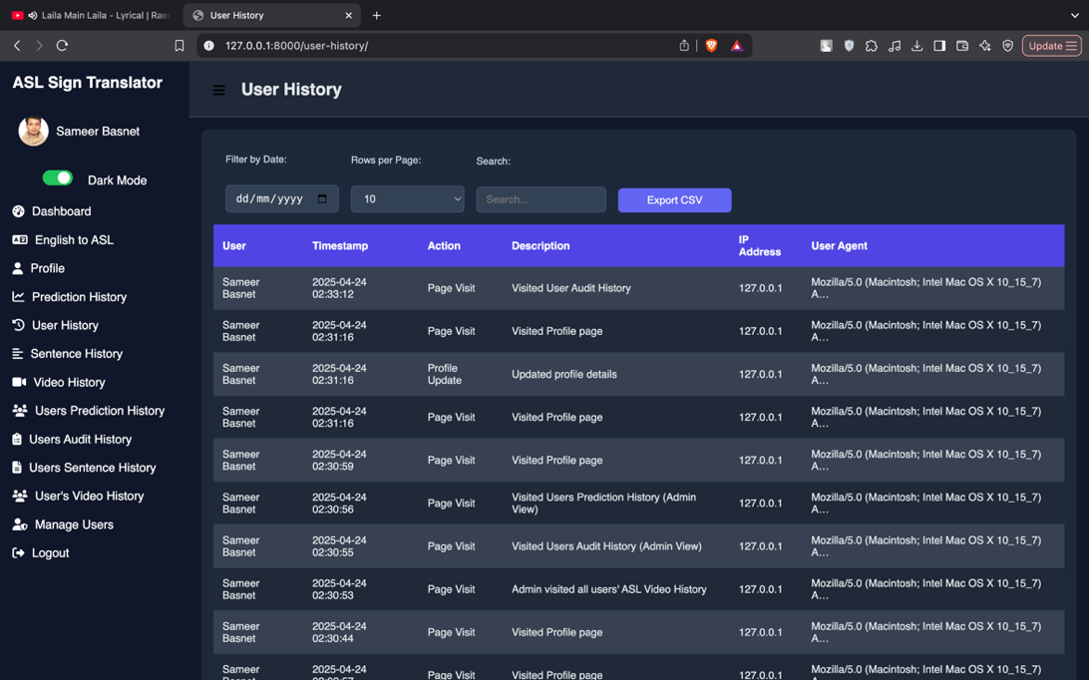

*Fig – 9: User History & Activity Log Page*

The user history page exhibits chronological activity logs—such as login times, action events, and alterations—permitting users to retrospect their past interactions and substantiating comprehensive visibility into their account usage history.

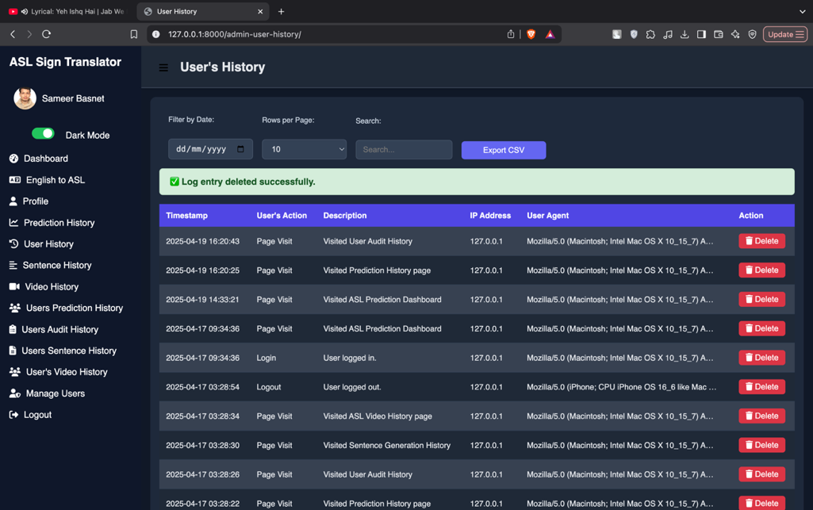

*Fig – 10: Admin User Activity Management Page*

The admin user history page lists entire user actions with view details and delete buttons, permitting administrators to audit activity logs and remove entries, substantiating comprehensive control atop user activity management.

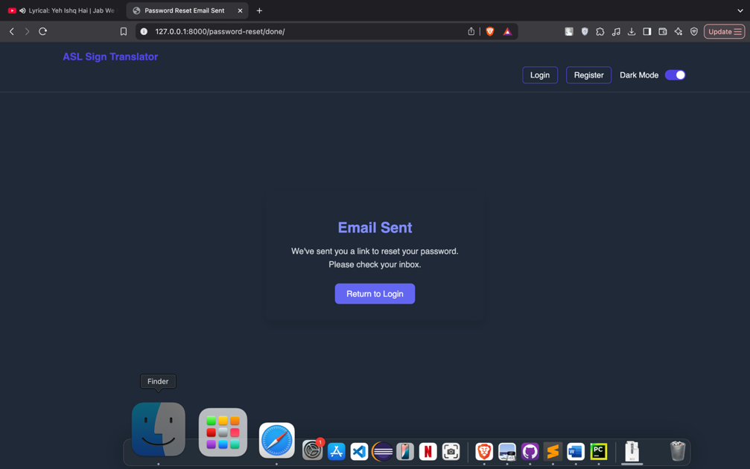

*Fig – 11: Password Reset Email Transmitted Confirmation*

When a user inducts password reset, the interface exhibits a confirmation message implying that the reset link has been transmitted through email, prompting the user to check their inbox and follow the provided instructions.

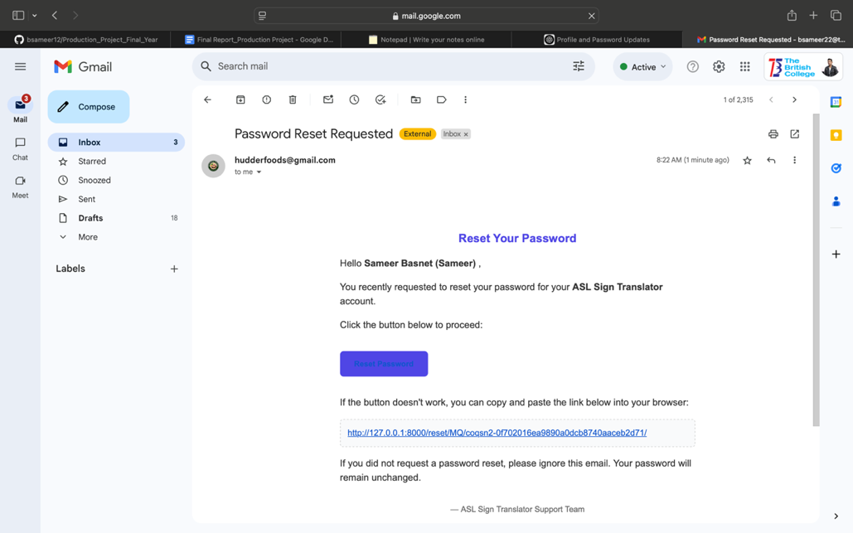

*Fig – 12: Password Reset Email Received*

The user’s email inbox exhibits the password reset message transmitted by the system, encompassing a secure link to constitute a new password, substantiating that the reset email was delivered appropriately.

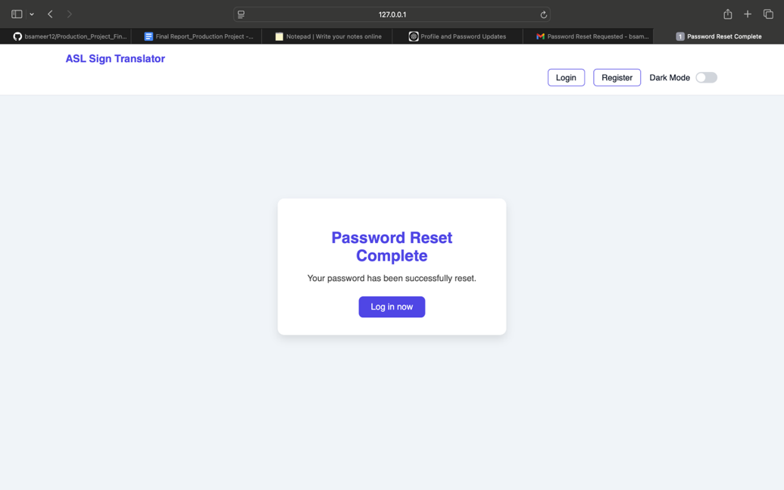

*Fig – 13: Password Reset Culmination Status Page*

After following the password reset link, users see a confirmation page stating that their password has been prosperous reset and are prompted to log in with the new credentials.

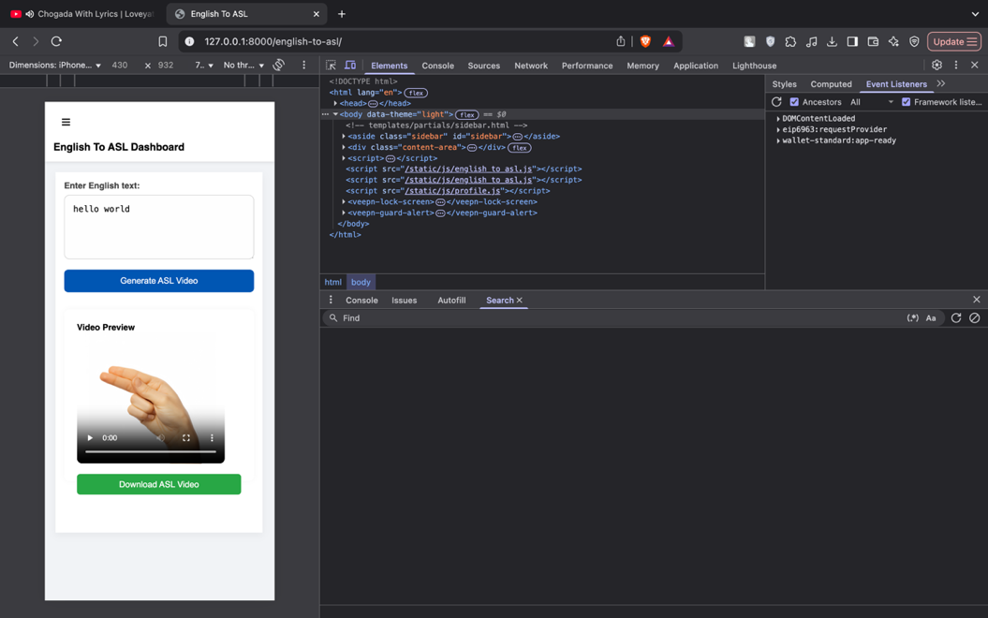

*Fig – 14: English-to-ASL Dashboard Responsive & Theme Assistance*

The dashboard adapts flawless throughout devices and strives dark/light theme toggling, substantiating comprehensive responsiveness and user-friendly interface customization for enhanced accessibility and usability.